United Ways of Iowa

Drew Conrad, CEcD, CERP Director
Institute for Decision Making

April 16, 2020

March 16 – IEDA contacted IDM

March 17 – Survey launched

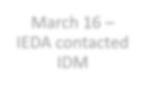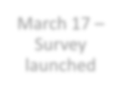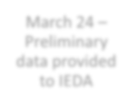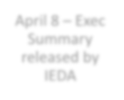March 23 – Survey closed**

** A few hundred surveys after
March 23 were also included
March 24 – Preliminary data provided to IEDA
April 8 – Exec Summary released by IEDA

13,905 completed surveys
from 99 counties & 742 different zip codes

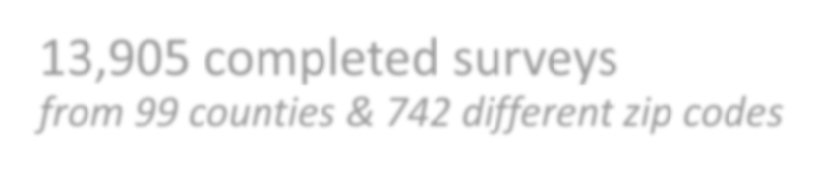• 85.0% For profit
• 10.5% Not for profit
• 2.6% Local government
• 1.0% State government

1,455 Respondents

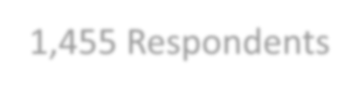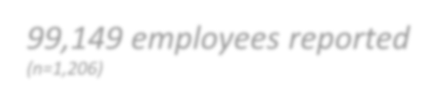99,149 employees reported
(n=1,206)

• 70.2% are full time
• Range from 1 to 8,700
• Mean = 82.21 employees
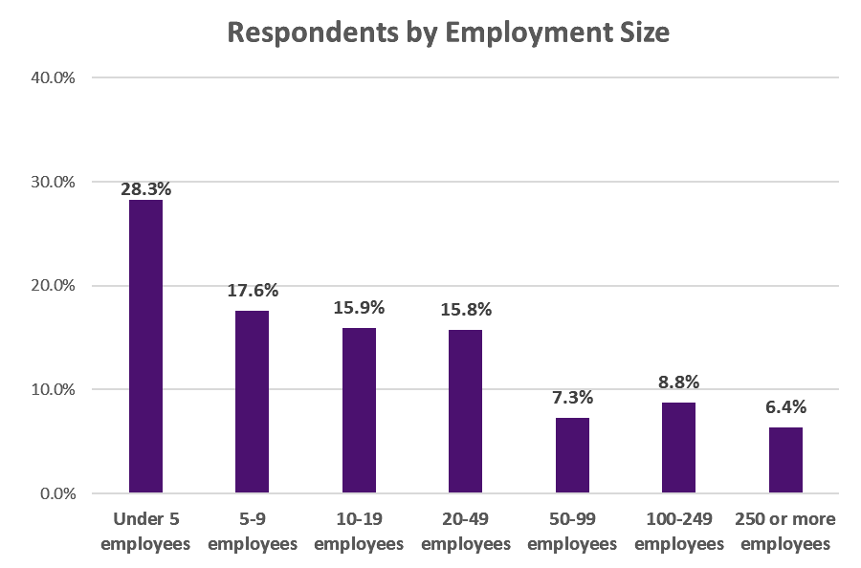• Median = 11.00 employees
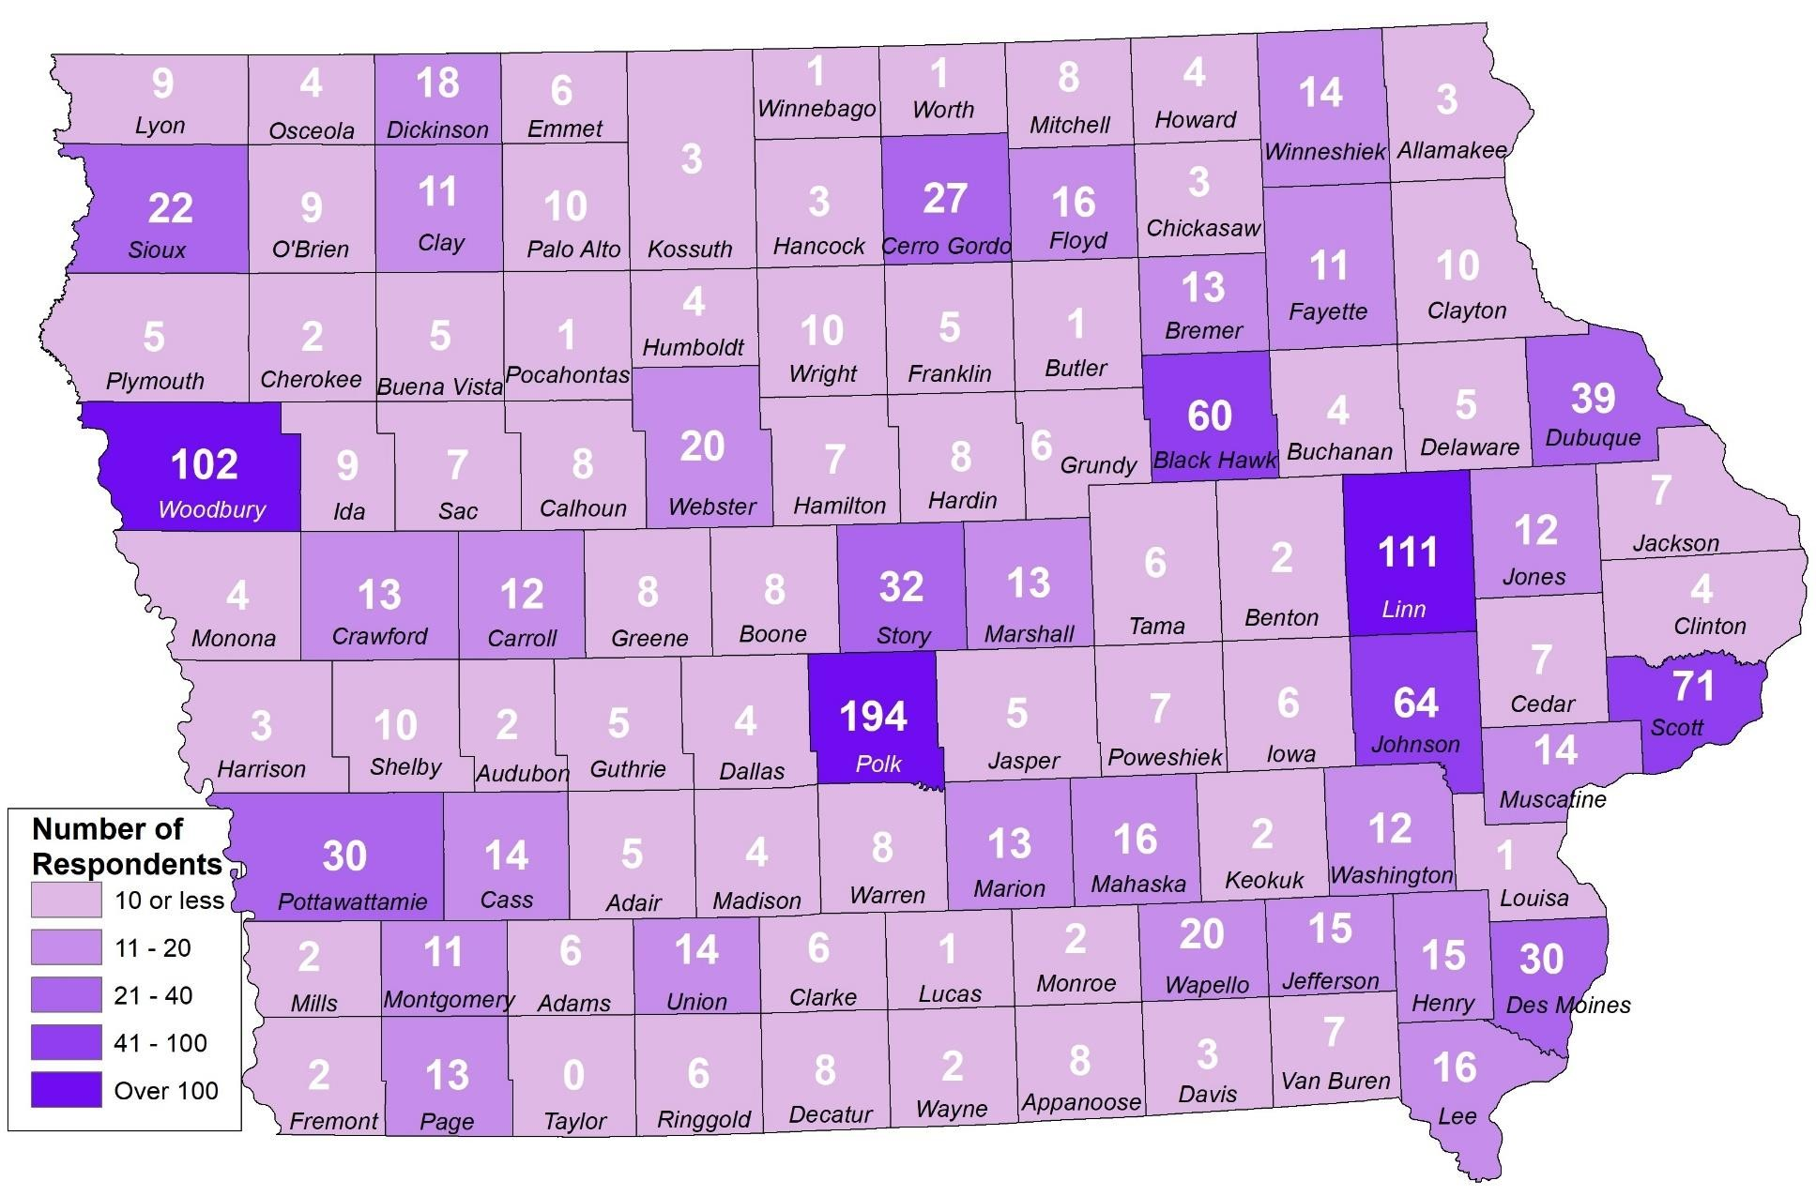

98 counties
✓ 54.6% metro
✓ 45.4% rural

0.0% 5.0% 10.0"/o 15.0"/o 20.0"/o 25.0"/o 30.0"/o 35.0"/o 40.0"/o

Health Care and Social Assistance  Other Services |  |  | 18.1% | 34.4%
Arts, Entertainment and Recreation |  |  | 17.3%
Educational Services  Finance and Insurance | 3.8% | 8.0%
Public Administration | 3.7%
Utilities - 2.4% Accommodation and Food Services - 2.2%
Retail Trade - 2.0% Agriculture, Forestry, Fishing and Hunting - 1.6%
Other - 1.2% Real Estate and Rental and Leasing • 0.9%
Construction • 0.8% Information • 0.8%
Professional, Scientific and Technical Services • 0.8% Administrative Support and Waste Mgt and Remediation Services • 0.8%
Transportation and Warehousing • 0.6% Not sure • 0.3%
Manufacturing 1 0.2%

Wholesale Trade 1 0.1% Management of Companies and Enterprises 1 0.1% Mining, Quarrying, and Oil and Gas Extraction 0.0%

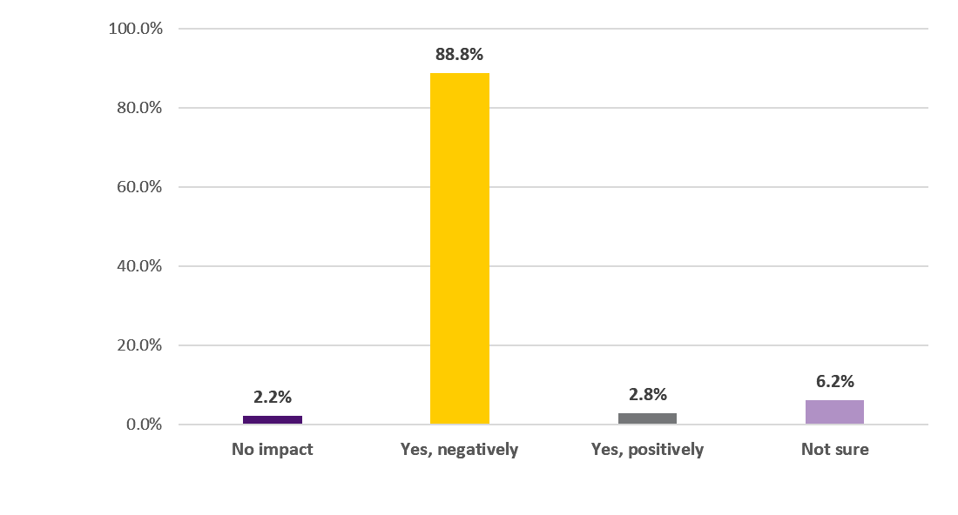

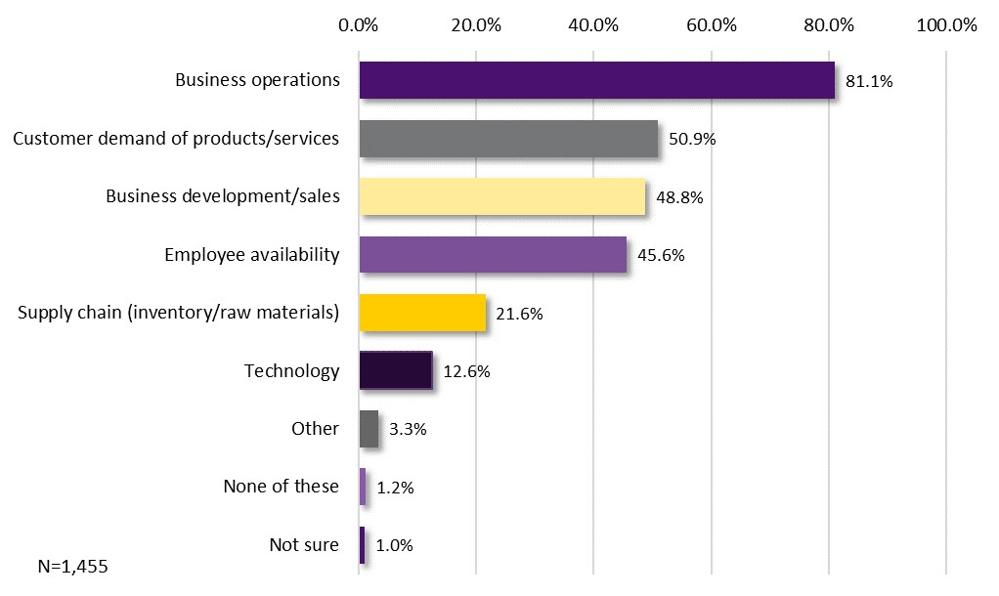

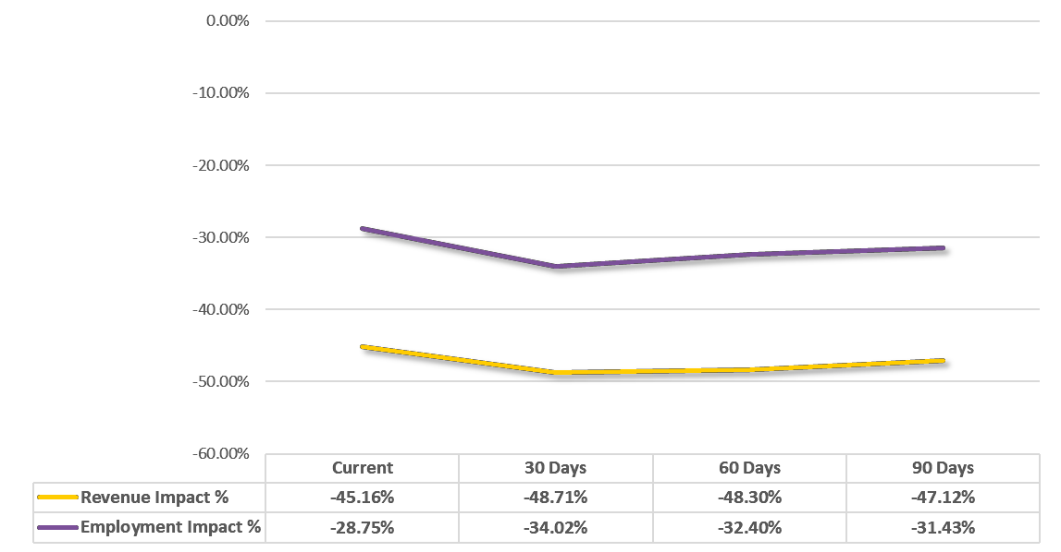

Average of Estimates

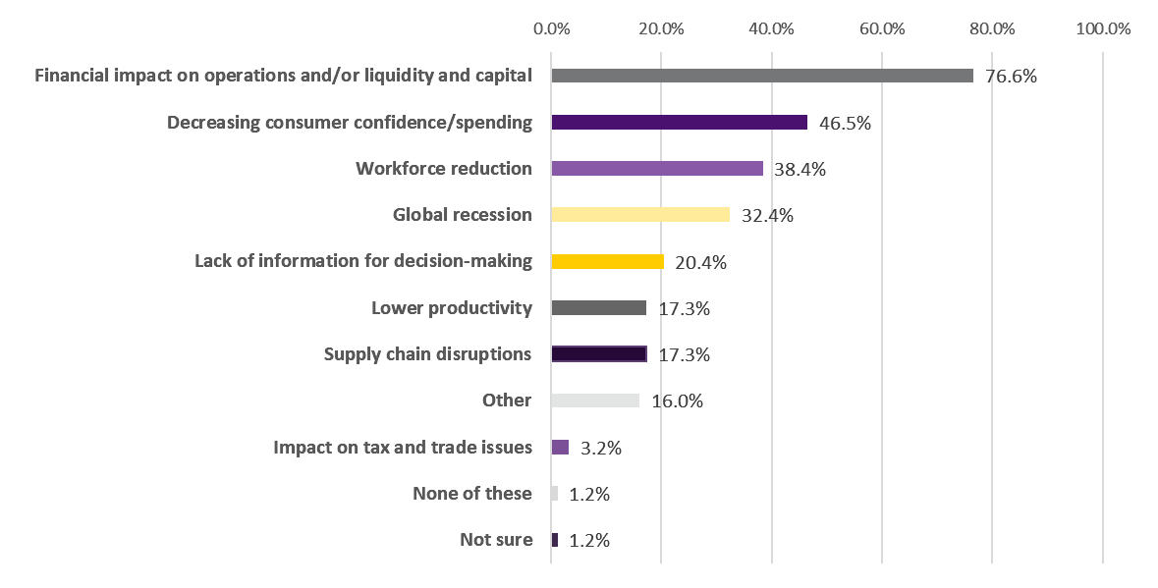Employee/client health & safety
Decreased fundraising
Not being able to meeting with clients
Community Impact

0.0% 20.0% 40.0% 60.0% 80.0%

Eligible employees have laptops and/or mobile phones Eligible employees have access to remote collaboration software Eligible employees have secure remote access to servers

Our organization has concerns about bandwidth limitations

Our organization has concerns about cybersecurity limitations

Eligible employees do not have access to necessary hardware/software at this time

Not sure

Not applicable

2.5%

0.0%

18.9%

17.2%

13.8%

44.9%

40.3%
64.6%
Financial Assistance | 40.5%
Financial Assistance - General, Access to Capital | 26.6%
To make payroll/cover sick pay/reimbursements for payroll | 4.4%
Grants | 4.0%
Low/no interest loans/forgivable/LOCs | 3.2%
Defer/delay/extend/restructure payments (accts payable: loans, utilities, rents) | 1.2%
For/in the future (reopening, long-term effects) | 0.7%
Tax credits | 0.4%
Communication and Information | 11.3%
Unemployment/Workers Comp | 6.9%
Laid off/underemployed/sick: direct payments to employees/financial and other assistance for employees | 4.1%
Unemployment Ins/workers comp: Policy changes (not count against employer, speed up benefit payments,  ease eligibility, for self-employed) | 2.3%
Unemployed/laid off/reduced hours: Continuation of health insurance for employees/self employed | 0.5%
Miscellaneous Ideas (testing, shut downs, reopens, workforce needs, requests to be “essential businesses”) | 6.7%
General Comments (political, story sharing, find a cure, stop the panic) | 4.9%
Supplies - protection related (hand sanitizer, PPE, etc.) | 4.3%
Technology Assistance and equipment for working remotely/online sales | 3.0%

Drew Conrad, CEcD, CERP Director
Institute for Decision Making andrew.conrad@uni.edu
319-273-6977

